EXERCISE NO : 14

DATE : 23/ 11/2020

AIM :

To write a python class to find validity of a string parentheses, ‘(‘, ’)’,

‘{‘, ‘}’, ‘[‘and‘]’.

PROGRAM :

def areBracketsBalanced(expr):

stack=[]

open_expressions=['{','[','(']

for i in range(len(expr)):

if(expr[i] in open_expressions):

stack.append(expr[i])

else:

if not stack:

return False

curr=stack.pop()

if(curr == '{'and expr[i]!='}'):

return False

if(curr == '['and expr[i]!=']'):

return False

if(curr == '('and expr[i]!=')'):

return False

if stack:

return False

else:

return True

if __name__ == "__main__":

expr=input()

if(areBracketsBalanced(expr)):

print("valid")

else:

print("invalid")

OUTPUT :

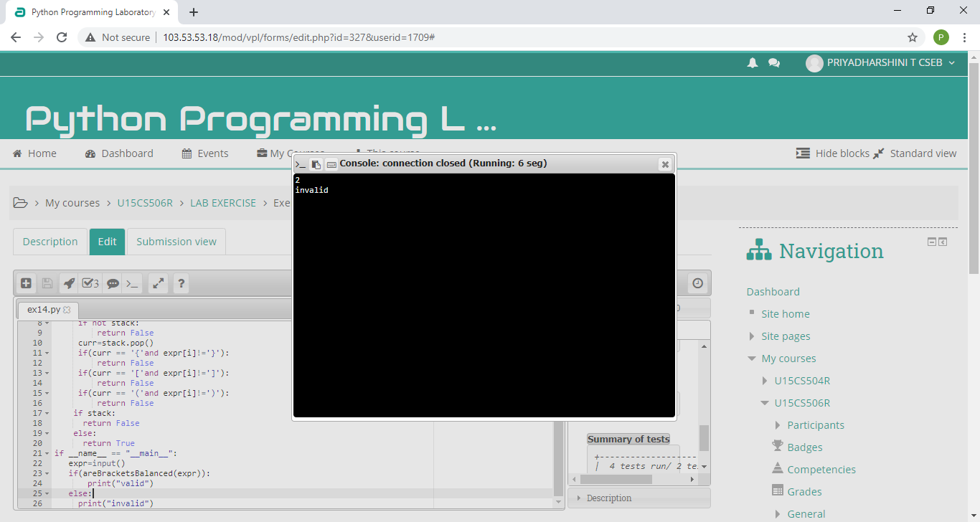

LINK :

<http://103.53.53.18/mod/vpl/forms/edit.php?id=327&userid=1709#>

RESULT :

Thus, the program is successfully executed and the output is verified.